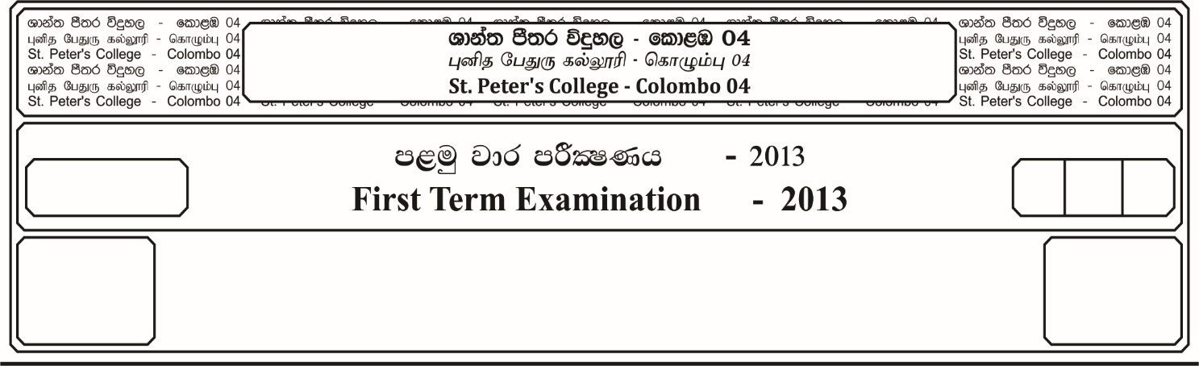

12 fY%aKsh

GRADE 12

E

$02$ meh

Two Hour

**m<uq jk jdr mÍCIKh - 2023**

**First Term Examination - 2023**

ixhqla; .Ks;h

**COMBINED MATHEMATICS**

10

* **Answer four questions only.**

01. a). Express as a rational number **0.1 $\dot{7}$ + 0. $\dot{1}\dot{2}$**

b). Solve the equation,

***x* - $\sqrt{x+1}$**  **= 5**

c). Solve the simultaneous equations.

***x* + y = 7**

***x*y = 6**

d). Solve the equation,

**– 24 =**

02. a). Find the domain and range of the following functions.

i. ***f* (*x*) = - 2 $x^{2}$**

ii. ***f* (*x*) = $\frac{2}{x-2}$**

iii. **f (x) = $\sqrt{4-x}$**

b). The arrow diagram shows,

part of the mapping **f : x $→$ $\frac{24}{ax+b}$** , **x $≠$- $\frac{b}{a}$*x $\frac{24}{ax+b}$***

1

0

- 1

6

0

- 12

Find, i. The values of ***a*** and ***b***

ii. The element that has an image of **8** under **f**.

iii. The two values of ***x*** for which ***f (x) = x***

c). The functions **f : *x $→$* *x* – 5** and **g : *x $→$ $\frac{1}{x - 1}$* , *x $≠$* 1**

i. $fg (x)$ ii. $g^{-1}$ **o ${f }^{-1}$ (*x*)** iii. **gg (*x*)**

03. a). State the remainder theorem and prove it.

If ***f* *(x)*** is a polynominals of degree two when ***f (x)*** is divided by **(*x* - 1)**, ***x*** and

**(*x* + 1)** the remainders are **O**, **1** and **5** respectively. Find ***f (x)***.

b). Solve the equation,

$\log_{x}{2}$**- $\log_{4}{x}$ + $\frac{7}{6}$ = 0**

c). Express in partial fractions.

04. a). ABCD is a square of side 14 cm. Find

C

D

A

B

i. The length of the shaded region.

ii. The are of the shaded region.

b). Prove that $\frac{\sin{θ}}{1+ cos θ}$ **+ $\frac{1+\cos{θ}}{sin θ}$ = $\frac{2 sec θ}{\tan{θ}}$**

c). If **sin $θ$ = $- \frac{8}{17}$**  and ${3\overline{∧}}/2$ **< $θ$ < 2 $\overline{∧}$** then find value of **sin 2 $θ$**

d). Show that Sin5 $0^{o}$- Sin 7 + Cos = 0

05. a). The position vectors of three points **A, B** and **C** relative to the origin **O** are $\underline{p}$ **, 3 $\underline{q}$- $\underline{p}$**  and **9 $\underline{q}$- 5 $\underline{p}$** respectively. Show that **A, B** and **C** lie on the same straight line and state the ratio of **AB : BC**

b). The position vectors of the points **A, B** and **C** relative to origin **O** are

$\underline{a}$**= 4 $\underline{i}$- 3 $\underline{j}$, $\underline{b}$ = 2 $\underline{i}$ + 4 $\underline{j}$** and $\underline{C}$ **= 22 $\underline{i}$- 11 $\underline{j}$** respectively.

Find,

i. $\vec{AB}$ and $\vec{BC}$

ii. The angle **A $\hat{B}$ C**

iii. The value of the constant $λ$ and $μ$ for which $λ\underline{a}$ **+ $μ\underline{b}$ = $\underline{C}$**